First Proved it works

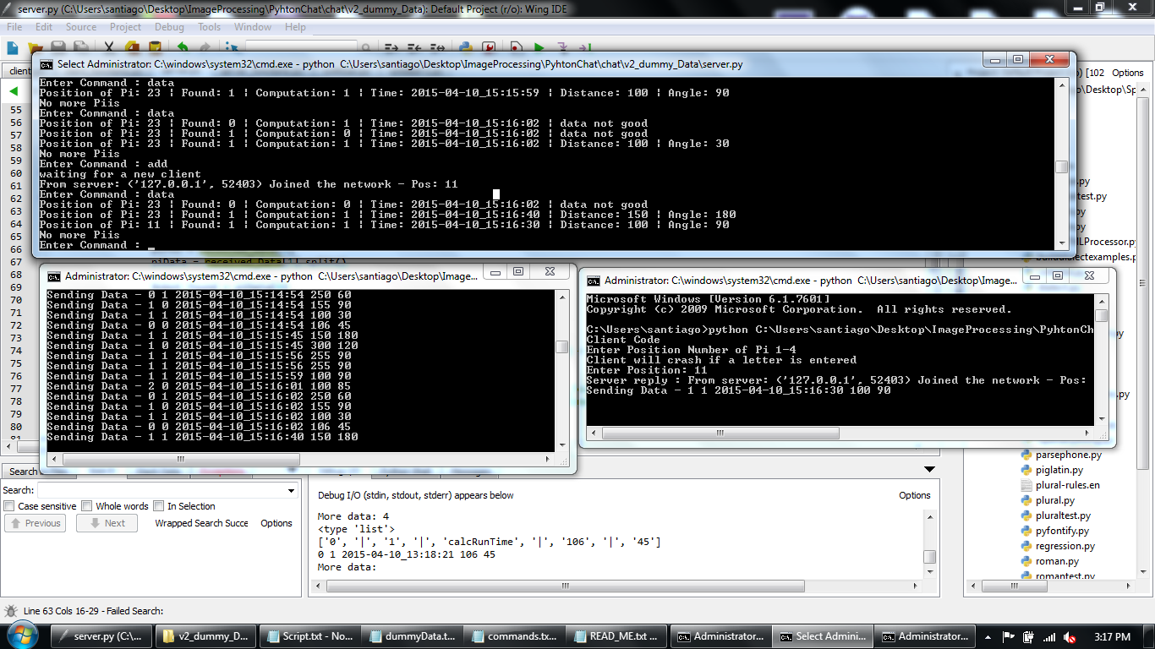

2 Piis working

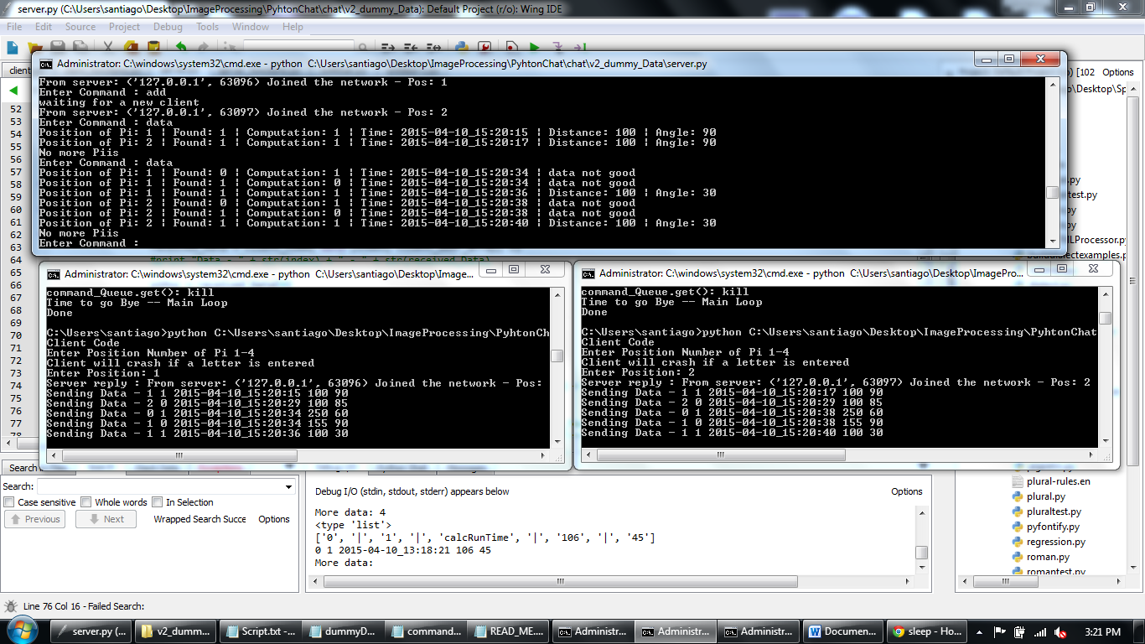

Proof

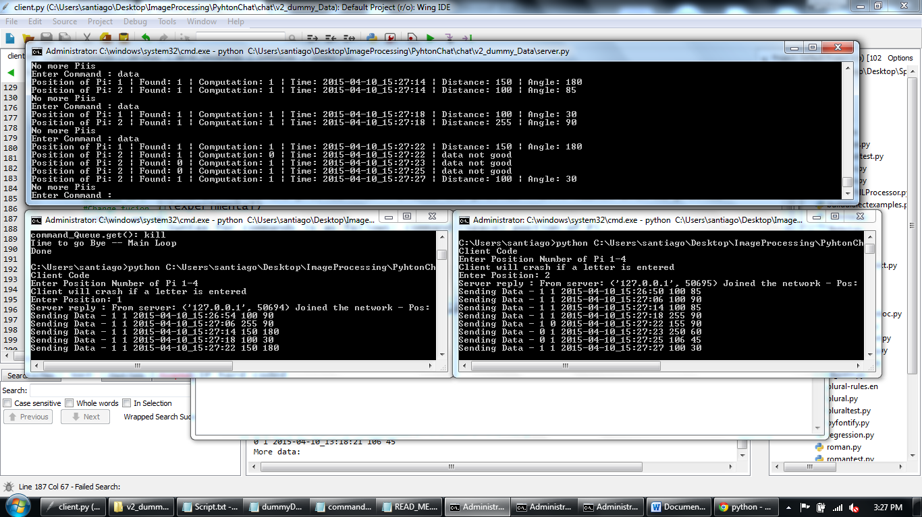

Simulation –

Step 1

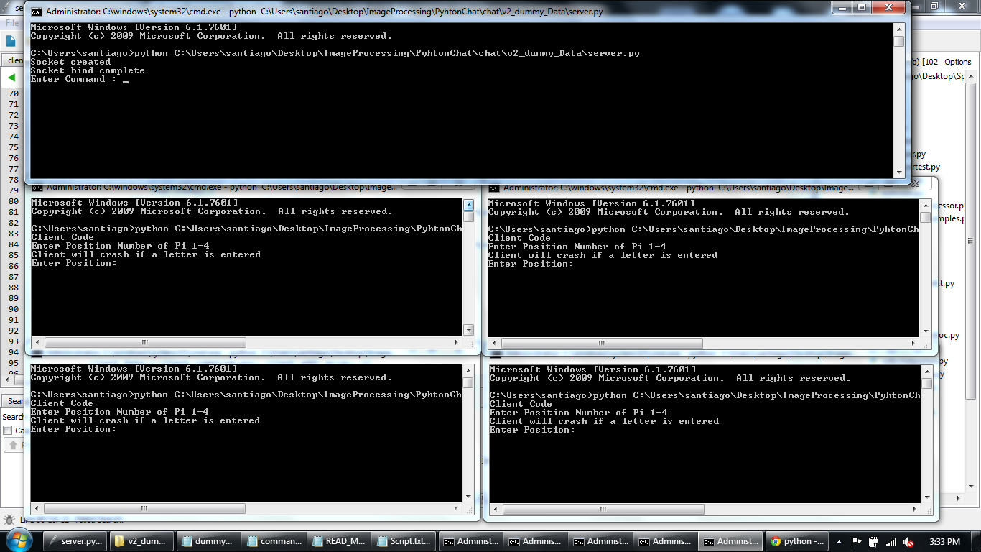

Step 2

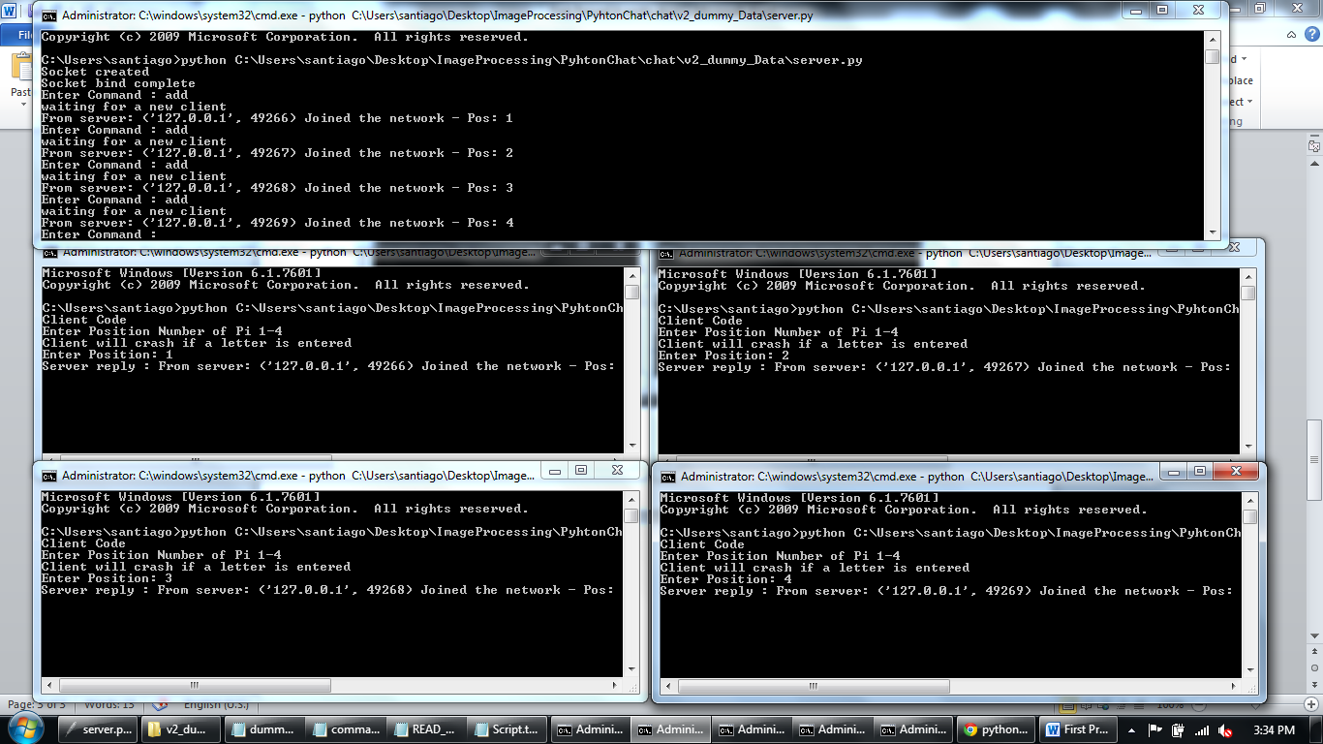

Step 3 – the data shown is pulled randomly from a txt doc

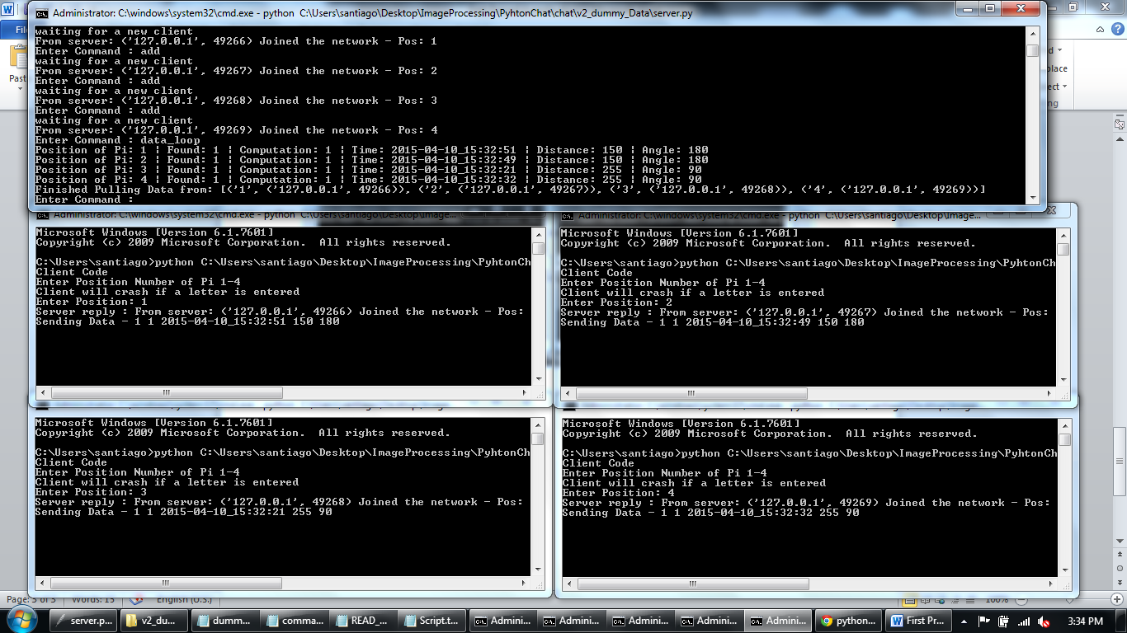

Step 4 – Shows that simulated Pi 4 gave an error 2 times

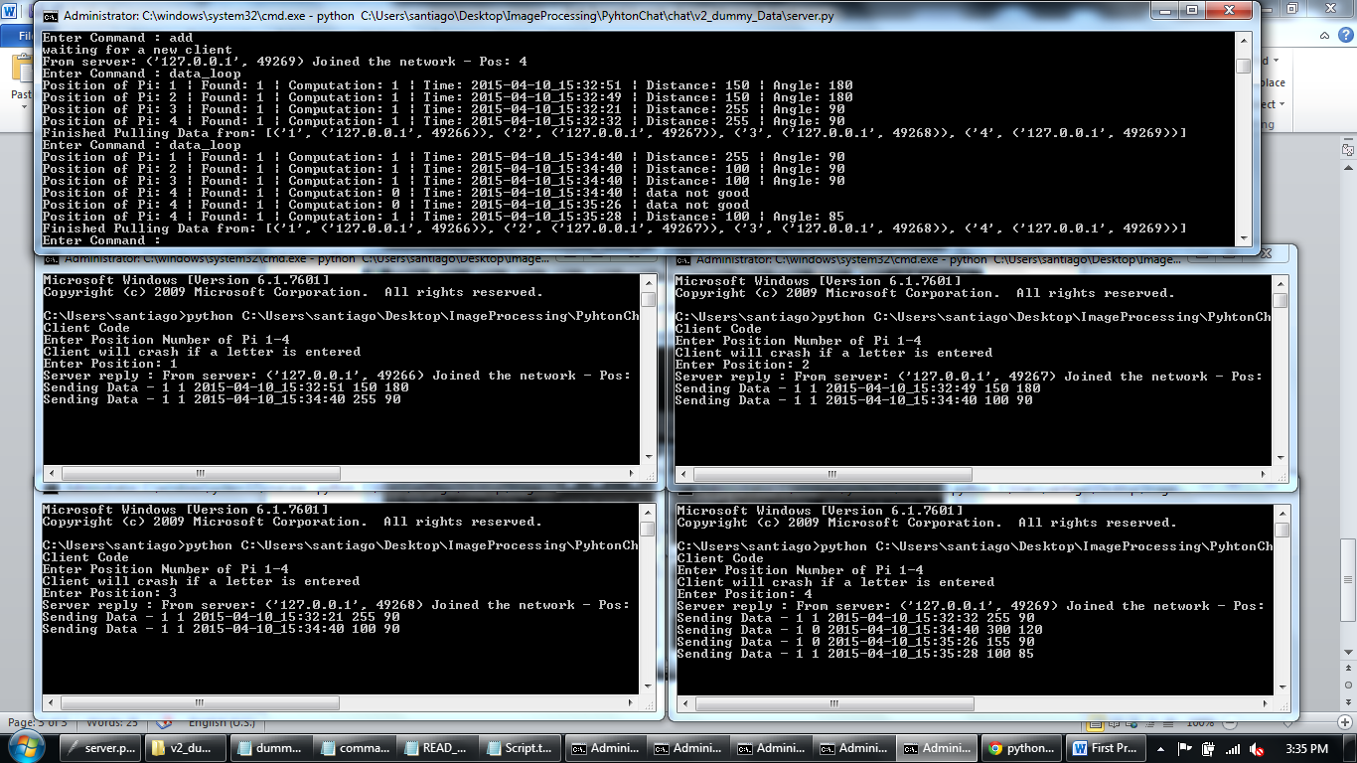

Step 5

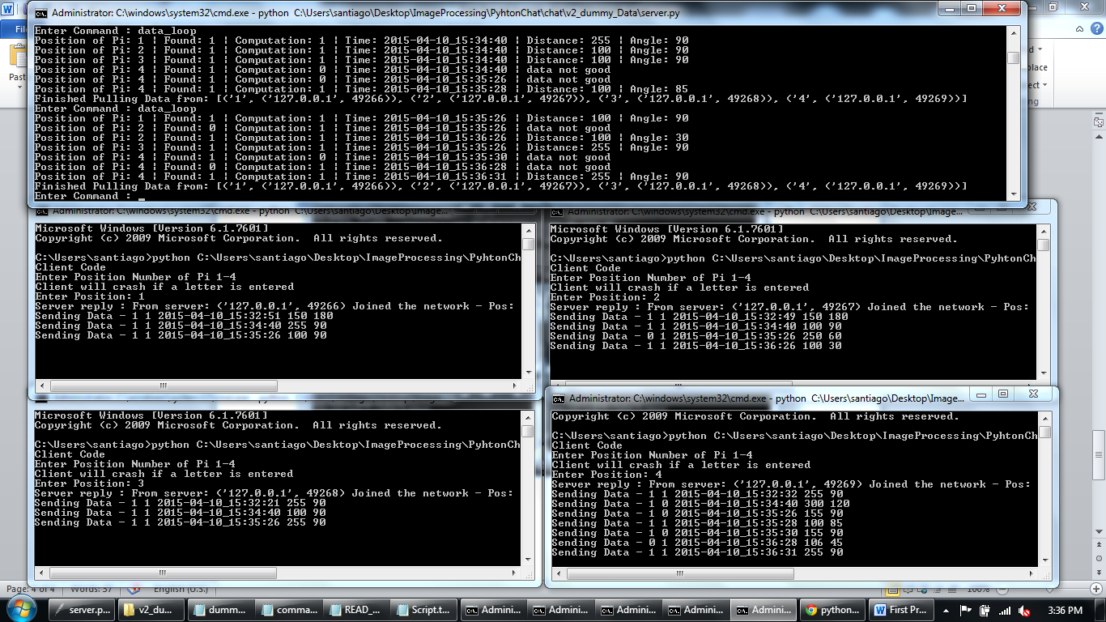

NOTES:

server Commands (case sensitive)

data 1 - returns raw data string (no error check)

state 1 - returns the state of the cleint's camera.

loop - requests data from all clients (no error check)

kill - Asks for index to kill

kill_All - kills all

exit - kills server and Client

show 1 - opens the preview - or - Closes the preview - Will launch with no preview (experimental)

Syntax for commands is as follows: command (space) postion of Pi

add - adds a pi to the network

data_loop - loops all the piis, if one send wrong data it asks for it again.